**TOPS TECHNOLOGIES**

**Software Engineering**

**Module No. 1**

**Assignment**

**Q.1 What is Software? What is Software Engineering?**

**Ans.** Software means the set of Instructions executed by any kind of tools. Software engineering is the systematic application of principles to design, develop and test software systems. It’s aim is to produce high-quality software in a less Budget, efficient time and with good Quality.

**Q.2 Explain types of Software?**

**Ans.** There are 2 types of Software :-

i) **System Software**

ii) **Application Software**

i) **System Software**

* These software programs are designed to run a computer's application programs and hardware.
* System software coordinates the activities and functions of the hardware and software.
* It controls the operations of the computer hardware and provides an environment or platform for all the other types of software to work in.
* The OS is the best example of system software; it manages all the other computer programs.

ii) **Application Software**

* The most common type of software, application software is a computer software package that performs a specific function for a user, or in some cases, for another application.
* An application can be self-contained, or it can be a group of programs that run the application for

the user.

* Examples of Applications include Microsoft Office, Paint, Powerpoint etc…

**Q.3 What is SDLC? Explain Phases of SDLC?**

**Ans.** Full Form Of SDLC is Software Development Life Cycle.

It is a step by step approach to develop product or application Software with high quality, Less time and maintain Budget.

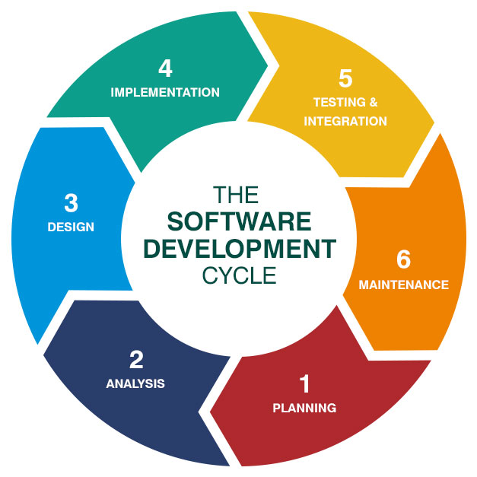

There are total 6 Phases of SDLC :-

i) Planning

ii) Analysis

iii) Designing

iv) Implementation

v) Testing

vi) Maintainence

i) Planning :- In this phase the person is asked to identify the goal of the customer, see the scope and feasibility.

ii) Analysis :- In this step developer gathers the information and document the business and also ask for Technical Requirement.

iii) Designing :- In designing the developer construct the design and specialisation for the system.

iv) Implementation :- It means to write the required code which is required for the programming and compile it to build the system.

v) Testing :- In testing the person from Quality Assurance tests the system and go through all the steps and check that the required things are put in this system or not and then the system is fixed.

vi) Maintainence :- In this last step company provides the ongoing support and updates for the costumers so that the customers can enjoy using it.

**Q.4 What is DFD? Create a DFD Diagram on Flipkart.**

**Ans.** DFD :- Data Flow Diagram

DFD means the Graphical Representative of the flow data of the system.

***LEVEL 0 DFD DIAGRAM***

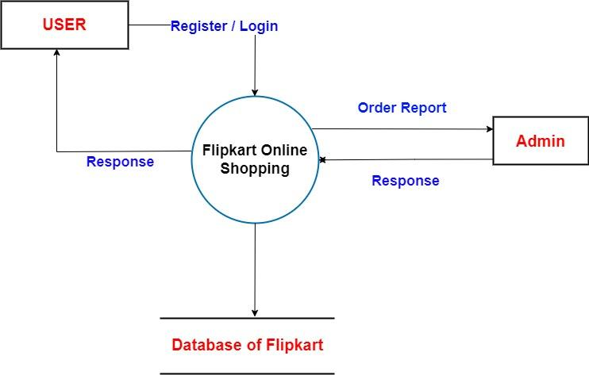

***LEVEL 1 DFD DIAGRAM***

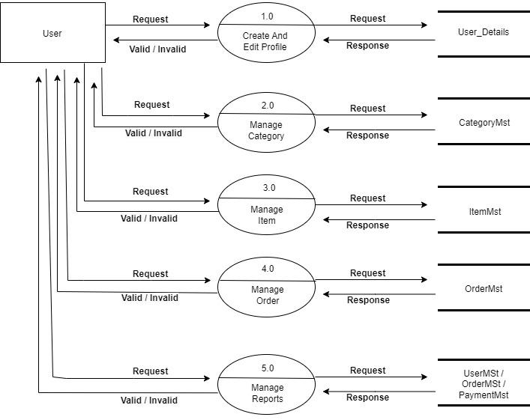

***LEVEL 2 DFD DIAGRAM***

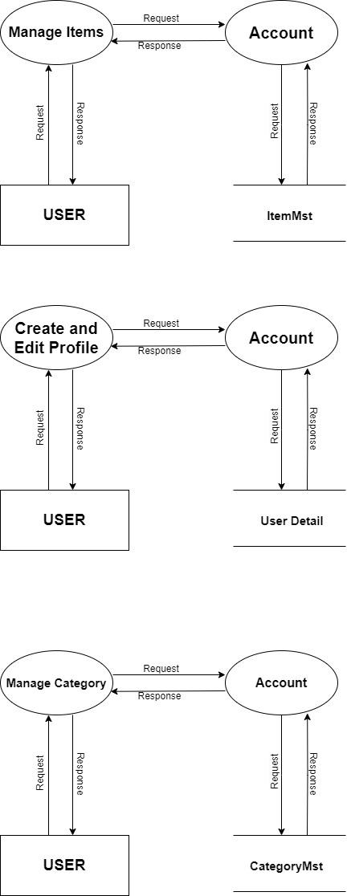

**Q.5 What is Flowchart ? Create a flowchart to make addition of two numbers.**

**Ans.** A flowchart is a diagram that visually represents a process or workflow, using standardized symbols to depict different steps and their sequence. It helps in understanding and analyzing the flow of activities within a system or process.

***Flow Chart of Addition***

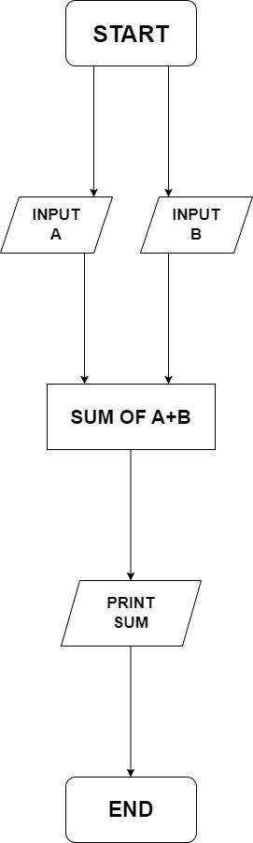

**Q.6 What is Use case Diagram? Create a use-case on bill payment on paytm.**

**Ans.** A use case diagram visually represents the interactions between users (actors) and a system, highlighting the system's functional requirements and the key ways users engage with it.

